Jack Melcher

67574625

EECS101

Homework1 Images

Problem 1 Images



Figure 1: Orthographic Projection

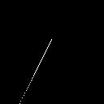

Figure 2: Perspective Projection

Problem 2 images (Orthographic)

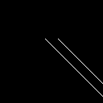

Figure 3: Orthographic Projection, z0 = -1



Figure 4: Orthographic Projection, z0 = -2



Figure 5: Orthographic Projection, z0 = -3

Problem 2 images (Perspective)

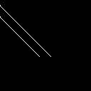

Figure 6: Perspective Projection, z0 = -1

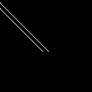

Figure 7: Perspective Projection, z0 = -2



Figure 8: Perspective Projection, z0 = -3

Problem 3 images (Orthographic)

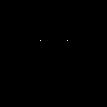

Figure 9: Orthographic Projection, b = 0, c = 1

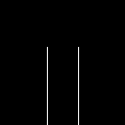

Figure 10: Orthographic Projection, b = 1, c = 1

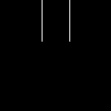

Figure 11: Orthographic Projection, b = -1, c = 1



Figure 12: Orthographic Projection, b = 0, c = -1



Figure 13: Orthographic Projection, b = 1, c = -1



Figure 14: Orthographic Projection, b = -1, c = -1

Problem 3 images (Perspective)



Figure 15: Perspective Projection, b = 0, c = 1

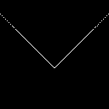

Figure 16: Perspective Projection, b = 1, c = 1

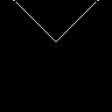

Figure 17: Perspective Projection, b = -1, c = 1



Figure 18: Perspective Projection, b = 0, c = -1



Figure 19: Perspective Projection, b = 1, c = -1

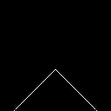

Figure 20: Perspective Projection, b = -1, c = -1